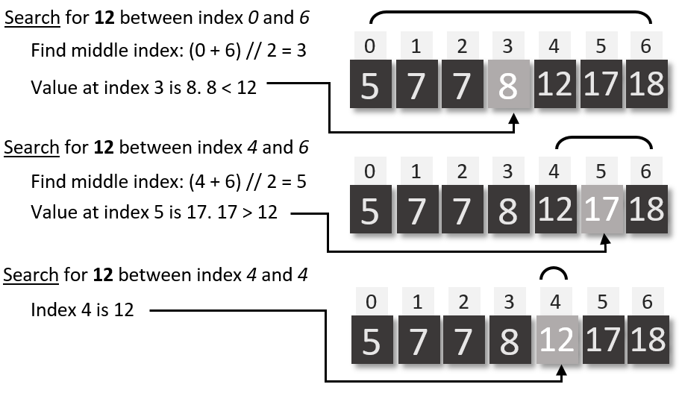

|  |  |  |
| --- | --- | --- |
| **E** | **Sort** | |
| **Bubble sort** | | A sorting algorithm which swaps adjacent items in a list if they are not in the right order, before moving onto the next pair. |
| **Insertion sort** | | A sorting algorithm which goes through a list by item, removes the item and puts it into the appropriate place in a new ordered list |
| **Merge sort** | | A sorting algorithm which splits a list in two, sorts each list recursively, then merges them back together |

|  |  |
| --- | --- |
| **F** | **Binary search** |

|  |  |
| --- | --- |
| **D** | **Search** |
| **Linear search** | A search algorithm which starts by looking at the first item in an unordered list, then moves to the second etc. |
| **Binary search** | A search algorithm which starts by looking at the middle term in an ordered list, then if the item is not found, recursively searching on the half of the list with the item in it |

|  |  |  |
| --- | --- | --- |
| **A** | **Key Vocab** | |
| **Iteration** | | Repeated execution of a group of instructions |
| **Condition controlled loop** | | An iteration statement which repeats until a certain requirement is met |
| **Count controlled loop** | | An iteration statement which repeats for a specified number of times |
| **Search** | | Find a specific item in a list of data using an algorithm |
| **Selection** | | A choice of which branch to take in a program, often with IF statements |
| **Sort** | | Arranging a list into an order |
| **Statement** | | An instruction or clause in a program |
| **Recursive** | | An algorithm which calls itself |

|  |  |
| --- | --- |
| **C** | **Selection structures** |
| **IF (ELIF) ELSE** | A selection statement which branches the program under certain conditions |
| **SWITCH CASE** | A type of selection statement where there are a number of possible branches |

|  |  |
| --- | --- |
| **B** | **Iteration structures** |
| **DO UNTIL** | Iteration structure which has a stop condition at the end of the loop |
| **DO WHILE** | Iteration structure which has a continuation condition at the end of the loop |
| **FOR NEXT** | Iteration structure which has an index variable, a step value and a stop condition |
| **WHILE** | Iteration structure which has a start condition at the beginning of the loop |

Programming: Structures